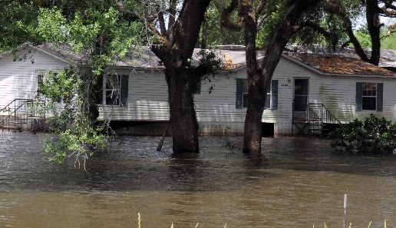
FEMA Photo/G Armstrong
Flooding occurs in all 50 states and is the nation’s most costly natural disaster.
LEARN YOUR PROPERTY’S
FLOOD RISK
Hurricanes, tropical storms and slow-moving rainstorms can create serious runoff and coastal flooding problems in Georgia. The result is frequent and costly flooding, not only in high-risk areas but in moderate- to low-risk areas as well. More than 35 percent of Georgia flood insurance claims come from lower-risk areas.
The [county’s/community’s] new digital flood maps show flood risks property-by-property. Your level of risk helps determine minimum building requirements and your cost of flood insurance. So, learn your risk. Go to [enter URL] to view the maps. [Include if applicable: You can pull up the map that shows your property. Just enter your address].
Questions about Georgia’s Flood MAP (Mapping, Assessment & Planning) program?
Visit www.GeorgiaDFIRM.com.
Questions about flood insurance?
Visit www.FloodSmart.gov or speak with your insurance agent.

FROM RELEASE TO
FINAL ADOPTION
New flood maps are targeted to become effective in [month/season—e.g., the fall of 2027]. At that time, any related flood insurance requirements will also take effect. The map adoption process includes a round of community meetings and a review of citizen concerns. Some property owners shown to now be in a high-risk zone may feel that their home or business sits high enough that it is not at high risk. An owner wishing to challenge the new designation must prove that the structure is sufficiently above the elevation that a major flood would reach (known as the base flood elevation). For more details on the appeals and comments process, visit www.GeorgiaDFIRM.com.
Mapping Milestones
[DATE]: Preliminary flood maps released
[DATE]: Open House Held; Public Review
[DATE]: Start of [90-day] Public Comment Period [(for filing of appeals and comment)]
[Target Date, Month or Season (e.g., Fall 2027)]*: New flood maps take effect; new flood insurance requirements also take effect
Visit www.GeorgiaDFIRM.com to learn more about the mapping process and where and when meetings may be held
For general information, call:
The [name of local call center or contact number] at [phone #].
Open [enter hours of operation].
* Date subject to change pending completion of review process

New Flood Hazard Maps for [county/community name]
What Property Owners
Should Know
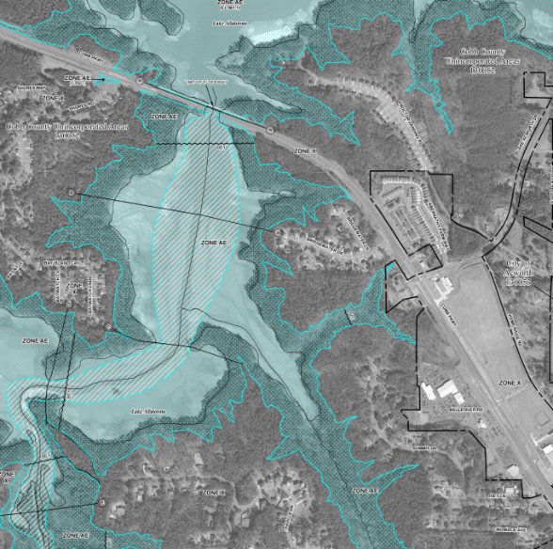

IDENTIFYING THE RISK
The first step in reducing flood risk is knowing your flood risk. Flood risks vary from neighborhood to neighborhood and even property to property, and they can change over time.
The likelihood of flooding in some areas has increased due to new development and environmental changes.
New detailed, digital flood hazard maps [are being/have been] developed to show current risk levels for [community name]. The new maps, known as Flood Insurance Rate Maps (FIRMs) replace maps that are based on outdated studies. Planners, local officials, engineers and builders will use the new maps to help determine where and how to safely build new structures and developments.
Residents and business owners can use the maps to learn their flood risk and decide the financial and physical steps they need to take to protect against damage and loss.
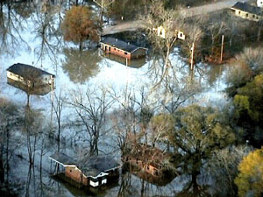
FEMA Photo/Liz Roll
¹ A BFE is the level that flood waters have a 1%-annual-chance of reaching or exceeding in any given year.

FLOOD MAPS AND FLOOD INSURANCE
With the release of the new flood hazard maps, some property owners will learn their flood risk is higher or lower than the previous maps showed. Others may discover that their Base Flood Elevation (BFE)¹ has changed. Certain changes in risk level can affect what you pay for flood insurance. The National Flood Insurance Program (NFIP) offers federally underwritten flood insurance that helps homeowners, business owners, and renters repair or replace buildings and their contents after a flood.
If you have a loan through a federally regulated or insured lender and are in a high-risk area (flood zones labeled with letters beginning with A [or V]), the federal government requires you to carry flood insurance as a condition of your loan.
If your property is newly shown to be in a high-risk area, the NFIP offers a rating option to help reduce your cost. But don’t wait until the new flood maps become effective to buy a flood insurance policy since you are at a high risk now. The chart below helps explain your options.
 | If Maps Show… | THESE REQUIREMENTS, OPTIONS AND SAVINGS APPLY
 | Change from moderate or low flood risk to high-risk (e.g., flood Zone B, C, or X to Zone A, AE, AH, AO[, V or VE]) | Flood insurance is mandatory. Flood insurance will be federally required for most mortgage holders.  NFIP rating option can offer savings. The NFIP offers a Newly Mapped discount if a policy is in place within 12 months after a new flood map becomes effective. Premiums will then increase no more than 18% each year.
 | [Change from high-risk Zone A or AE to higher-risk Zone V or VE or change in Base Flood Elevation (BFE)] | [Flood insurance is mandatory. Flood insurance will continue to be federally required for most mortgage holders.]  [Flood zones and BFEs are not used in rating an NFIP policy. This means there would be no change in premium when the map changes.]
 | Change from high flood risk to moderate or low risk (e.g., flood Zone [V, VE,] A, AE, AH, AO, to Zone X or shaded X) | Flood insurance is optional but recommended. The risk has only been reduced, not removed. Flood insurance can still be obtained, though there will be no change in premium due to the map change.  More than 35 percent of all Georgia flood insurance claims have occurred in moderate- and low-risk areas.
 | No change in  risk level | No change in insurance rates. However, this is a good time to review your coverage with your insurance agent and ensure that your building and contents are adequately insured.
Revised September 2024

